

**Smart Office Cleaner Robot**

**Team Members:**

MANMESWAR PATNAIK (TEAM LEADER)

YASHWARDHAN KAUSHIK

AJAY DEV PARMAR

SANCHIT KUMAR

ABHINAV PATIL

UPPALAPATI BINDU SRI SAI

NATASHA KARANJIA

*ELECTRONICS DEPT.*



*CS/IT*

*MECHANICAL DEPT.*

**Content**

|  |  |
| --- | --- |
| **No.** | **Contents** |
| 1 | Client Problem Statement |
| 2 | Product Objectives |
| 3 | Market Research |
| 4 | Stakeholder Survey |
| 5 | Idea Description |
| 6 | Design and Development Description |
| 7 | Product Rendering Images |
| 8 | Components Used with Description **(Mention the purpose of each component)** |
| 9 | Electronics/ Circuitry Diagram |
| 10 | Software Used and Micro-Controller |
| 11 | Codes **(Include everything that you all did for the product)** |
| 12 | Working Description **(Include flow diagrams)** |
| 13 | Product Advantages |
| 14 | Product Limitations |
| 15 | Final Product Specifications **(Include runtime, unique features, etc)** |
| 16 | Product Expected Life Cycle **(Include servicing, maintenance and replacement of parts)** |
| 17 | Cost Sheet |
| 18 | Product Handling and Safety Requirements |
| 19 | Product Innovation |
| 20 | Future Scope **(Include the probable components)** |
| 21 | Conclusion |
| 22 | Improvement Suggestions **(Each team member’s 1page suggestion)** |

**G5 - SMART OFFICE CLEANER ROBOT**

**CLIENT PROBLEM STATEMENT:**

Main demand of our client was to present them with an affordable and compatible robot for a healthy and clean environment.

**PRODUCT OBJECTIVES:**

Main goal is to prepare robust, inexpensive affordable product with better efficiency.

**MARKET RESEARCH & STAKEHOLDER SURVEY :**

A market survey was done with google form and asked within a variety of population. The group members shared the google form within their known people and the % of the response is as shown below.

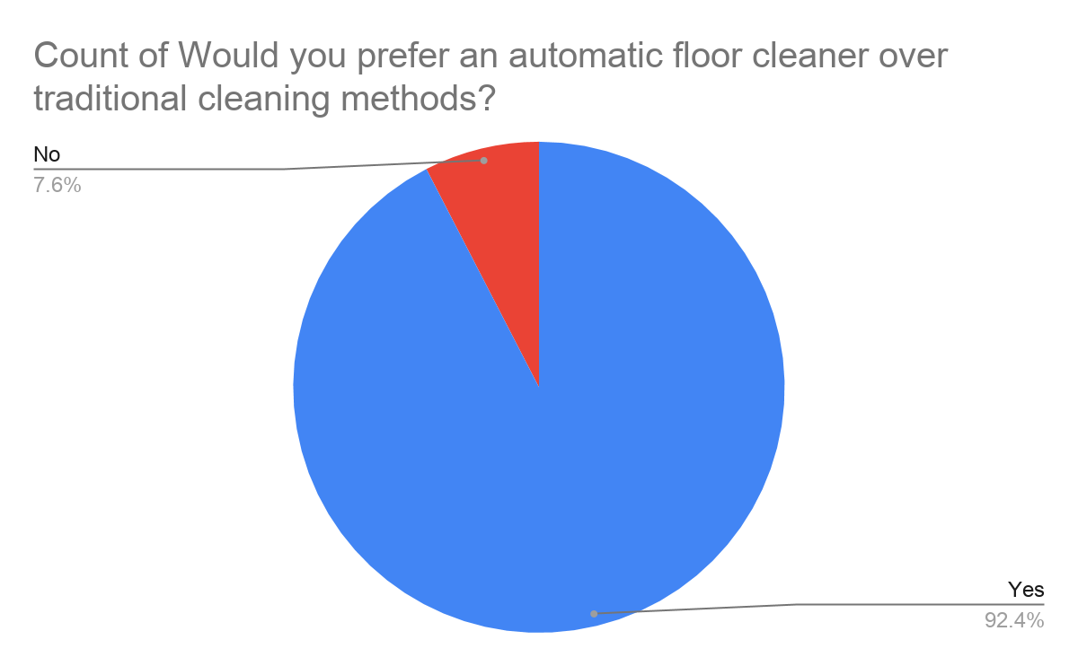

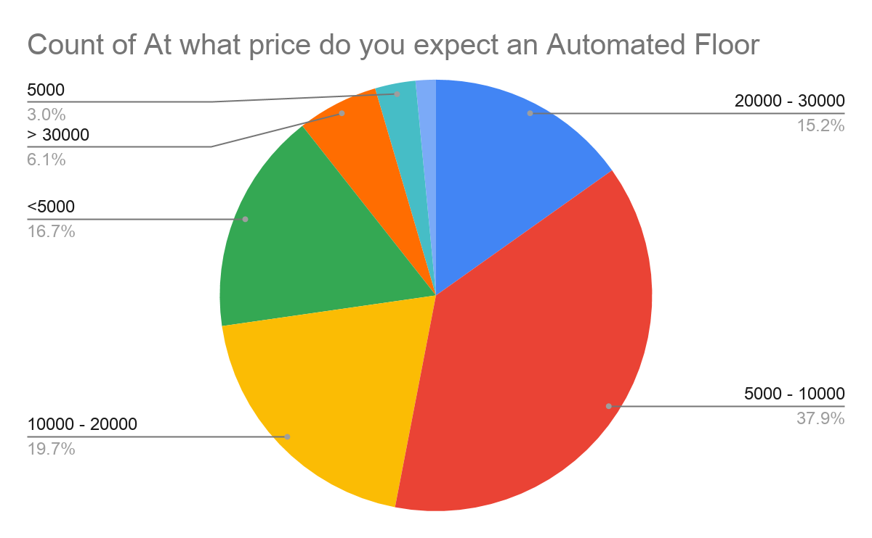

Through the following survey customers also suggested for some features and gave ideas to enhance our bot. Some of the most asked demands were:

“ Ability to monitor health and regulate dust cleaning accordingly so that the ones with dust allergy and other respiratory problems especially , would not suffer much”

We tried to identify such responses and acquired as many as possible.

**IDEA DESCRIPTION:**

Our main goal was to prepare a robust, inexpensive affordable product with better efficiency. Based on the above shortlisted point, we started researching on earlier bot practical concepts. The research made by the team helped us gain tremendous knowledge regarding the design and the components. On an unified note a smart cleaning robot with vacuum pump and wet mopping and UV Sanitization bot was to be made with two way working i.e. automatic as well as manual mode, also it should be compatible and efficient system within affordable range

**DESIGN AND DEVELOPMENT DESCRIPTION :**

After the research we started developing initial concepts as shown below,

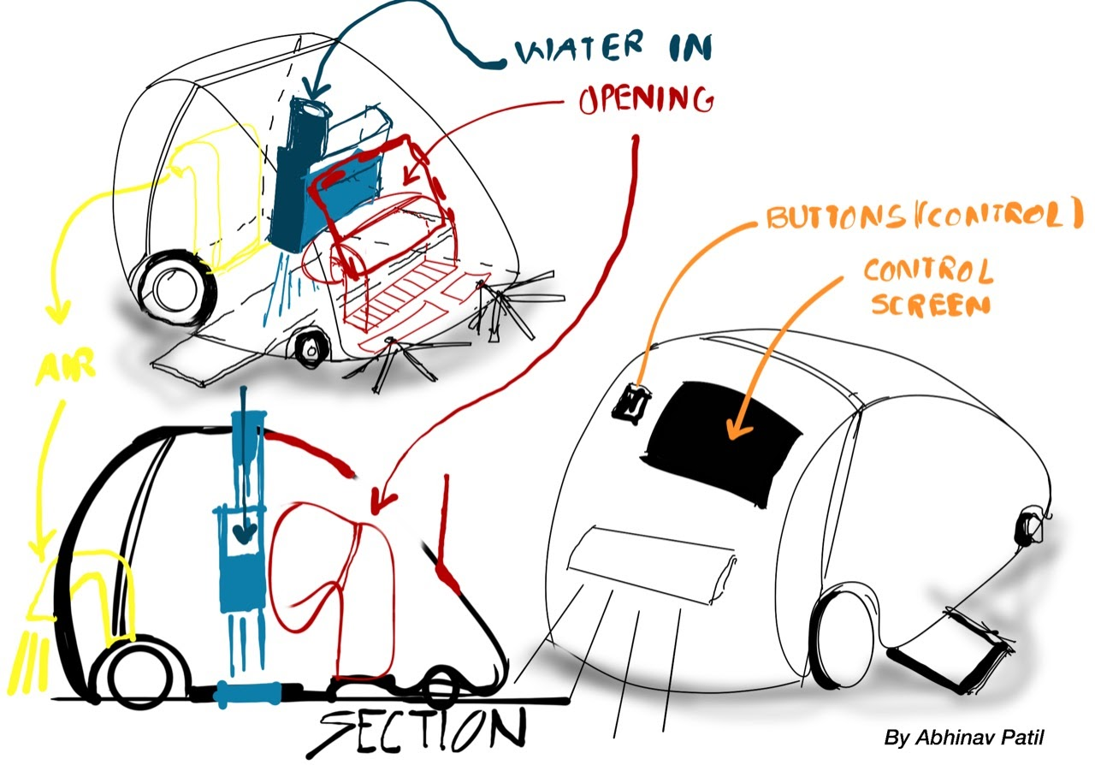 **Concept 1.1**

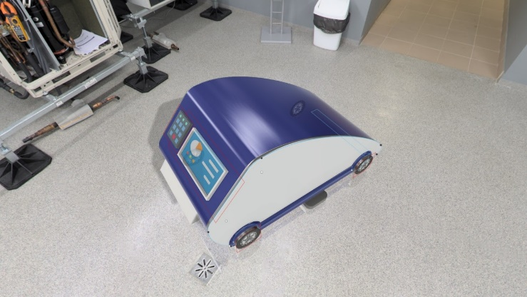 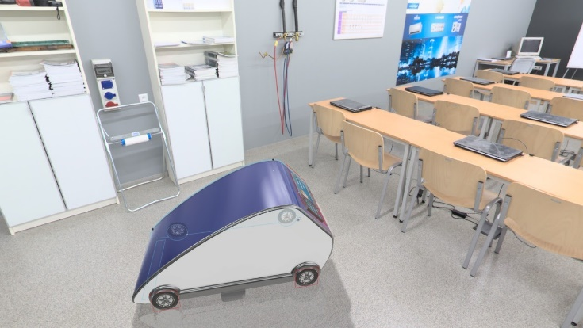

The initial concept 1.1 didn’t worked out well as the product specifications were too bulky, but was practical. Based on the reviews from the jury members we decided to work on another but an improved concept.

The second concept was based on compact and more efficient design. Where we started focusing more on electronic components, the hardware components as well as the aesthetics.

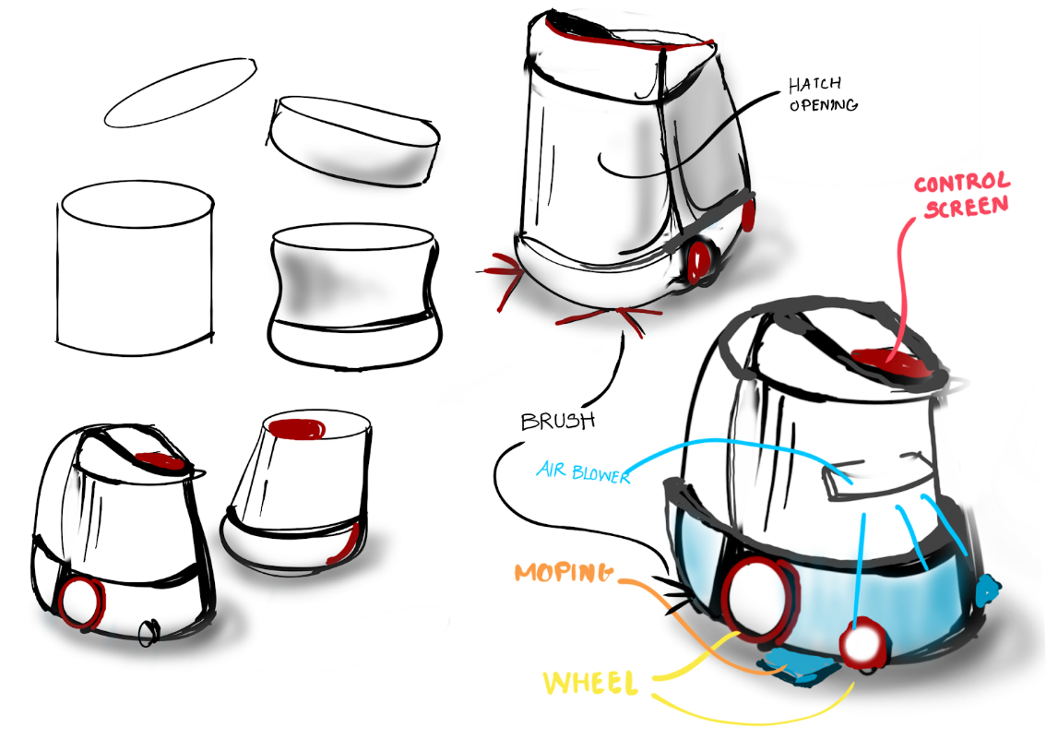

**Concept 1.2**

This concept was pretty much acceptable as the size of the bot was 550 x 350 x 300mm (l x b x h). One of the most unique bots workable for the market. We had various components included inside along with various features.

Refer few renderings below.

**PRODUCT RENDERINGS:**

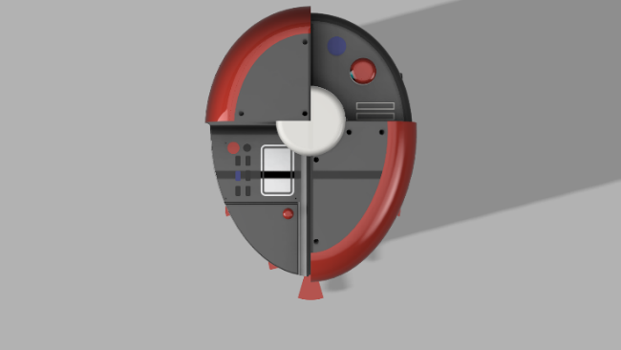 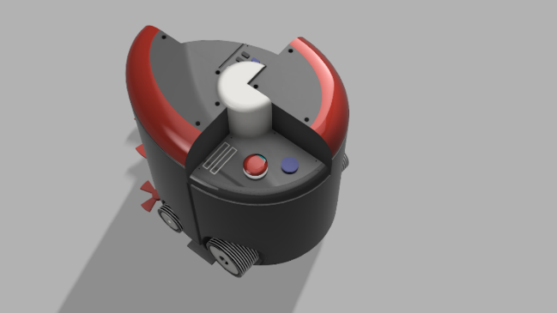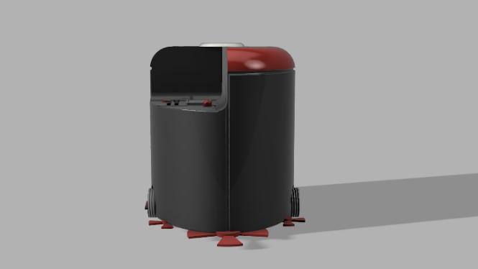 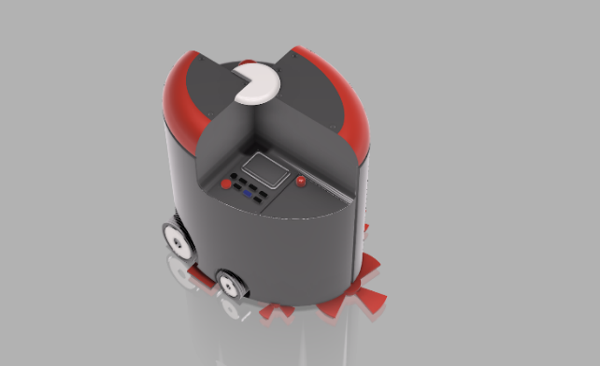

**COMPONENTS USED AND MAINTAINANCE**

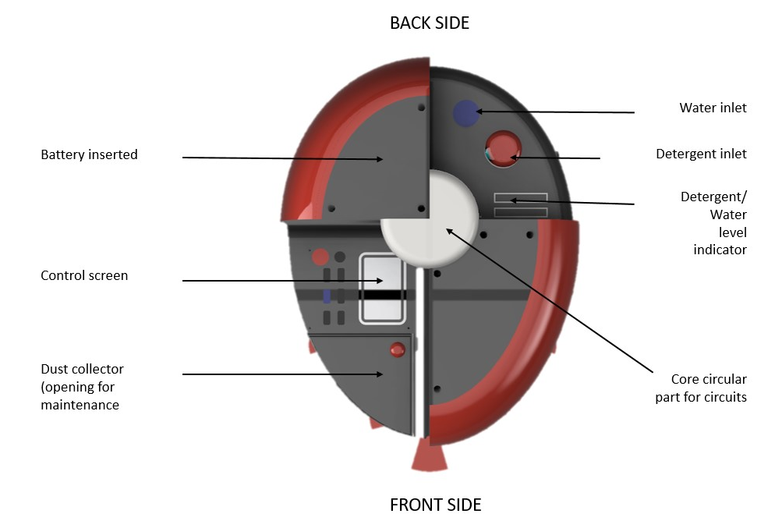

**TOP VIEW & Basic Components of the Robot**

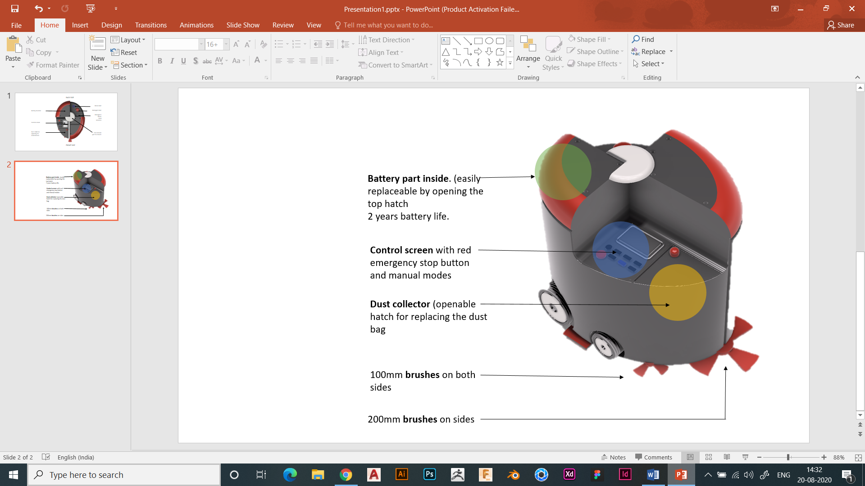

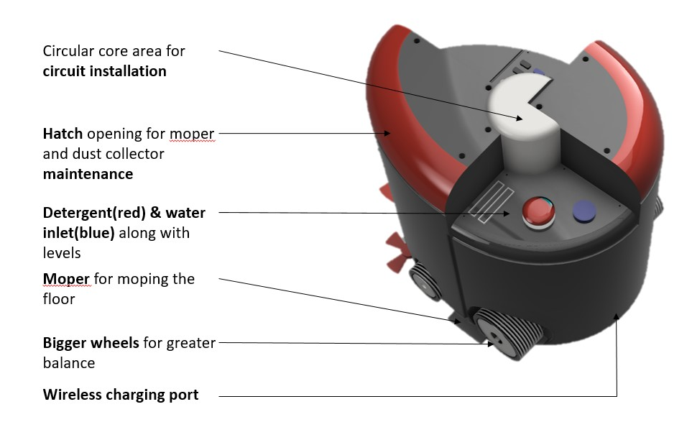

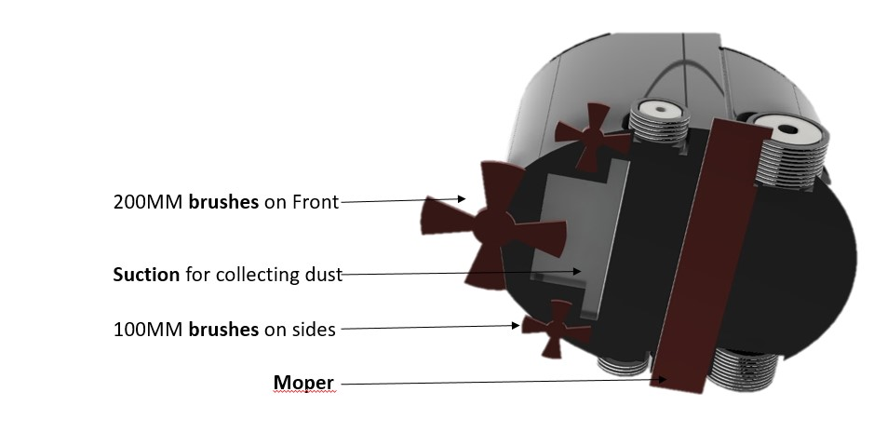

**ELECTRONICS/ CIRCUITRY DIAGRAM :**

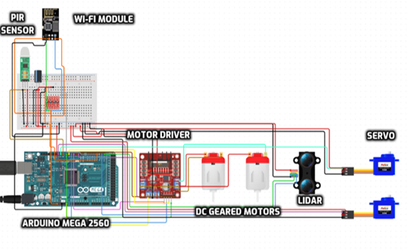

**COMPONENTS USED AND THERE USES:**

1. Arduino Mega: Required for the connection and start the sensors.
2. Raspberry Pi: To control the Arduino and LIDAR mapping.
3. LIDAR/Ultrasonic Sensor: To mapping and detecting.
4. PIR: To detect a moving object.
5. RTC: To track the current Time and Date.
6. DC Gear Motor: To move the wheels of robot.
7. **Motor Drivers: They act as an interface between the motors and Arduino.**
8. **Servo Motors: For rotating the brushes.**
9. **Battery: For providing extra power supply for heavy sensors.**

**10. Vacuum Pump: Sucking up the dirt.**

**11. LCD: For viewing the mode and battery**

**SOFTWARE USED AND MICRO-CONTROLLER :**

Apart from the automatic cleaning an application is also developed so that manual control to the device is also done.

A hardware prototype android mobile application has been developed also for making floor cleaning process easy, fast and comfortable, for giving commands The app shown below is used to send commands to the robot using the Wi -FI receiver connected to it.

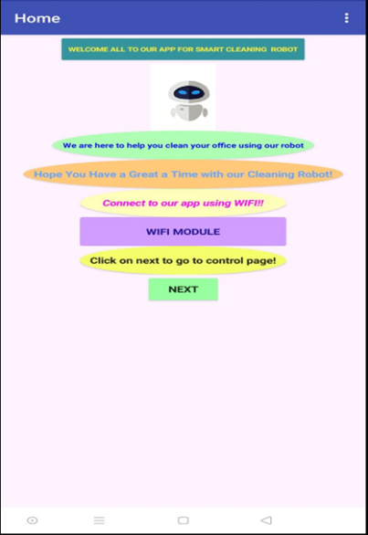

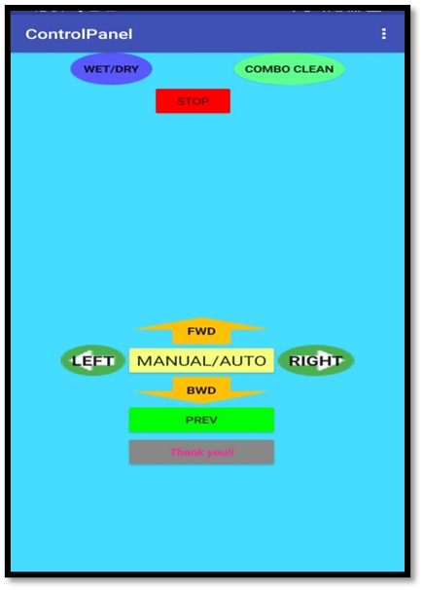

**Codes :**

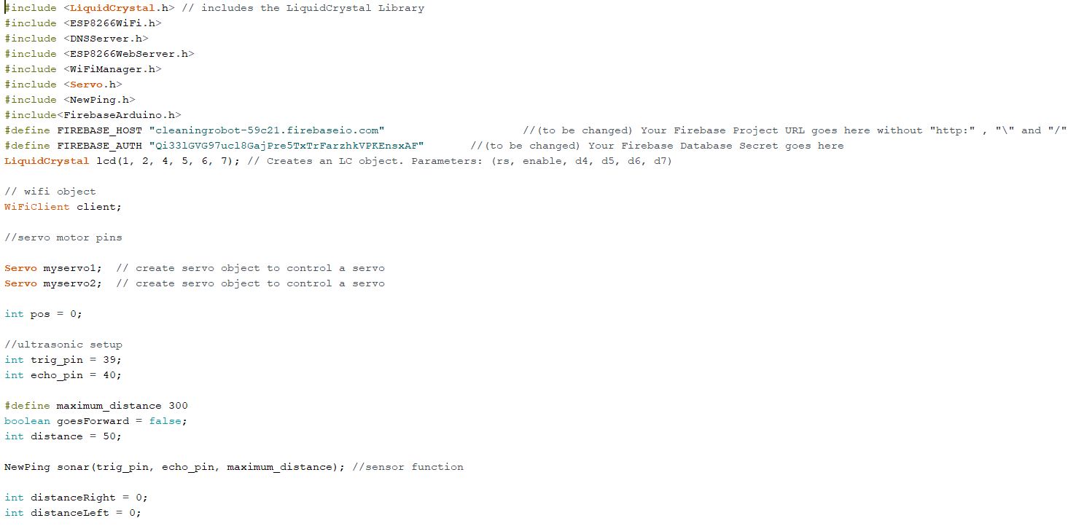

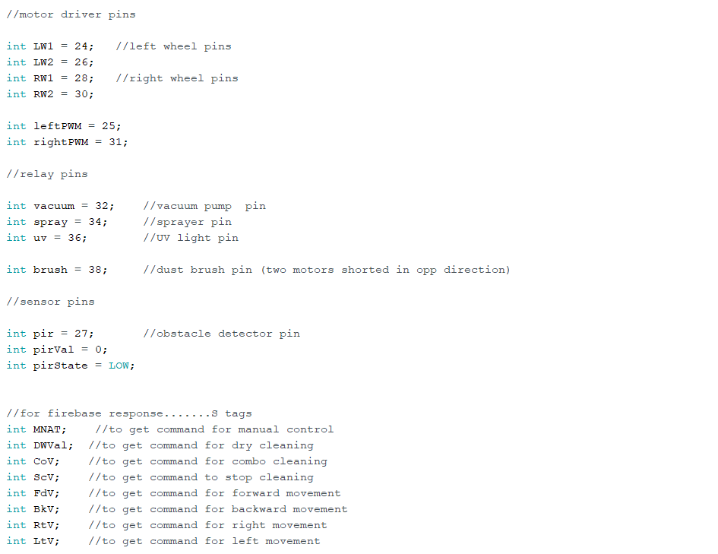

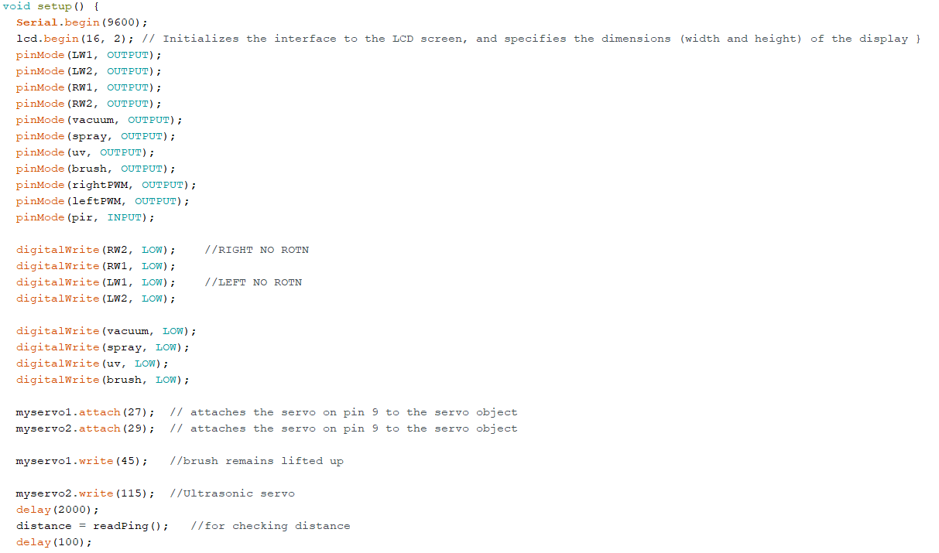

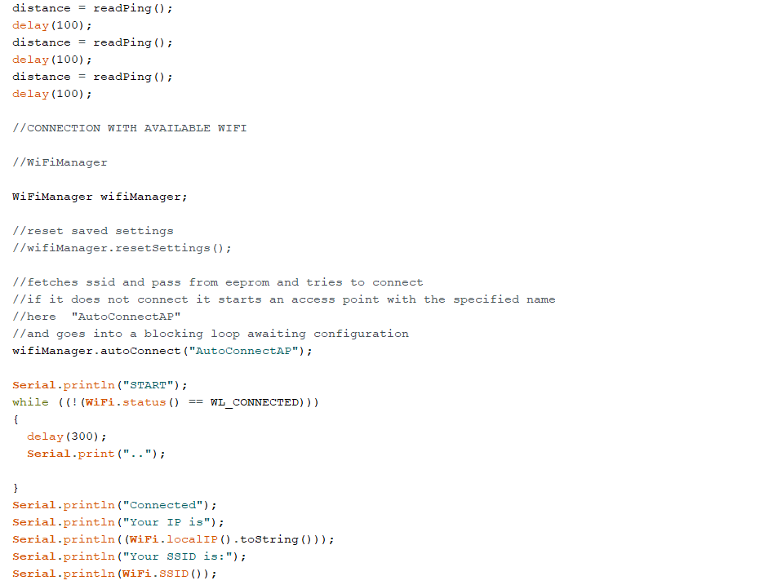

Hence the further more description with the code of the bot system can be found in the link given below !

<https://drive.google.com/file/d/1uGjQ3rTxsgF8WYT7OMDnzYcQUOxir58F/view?usp=sharing>

**WORKING DESCRIPTION :**

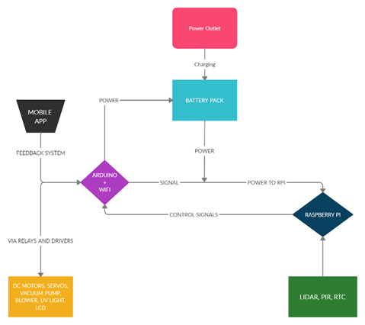

In the following flow chart, the basic connections of circuit are explained.

At first, we get the power supply from a power outlet like a 3-pin plug or a socket which will charge the battery at it’s maximum capacity and battery getting full the charger will automatically disconnect the power supply from the battery, then the battery will supply the power to Arduino and Raspberry Pi.

After power is supplied to Raspberry Pi send control signals to Arduino start the systems while simultaneously receiving commands from mobile about what to do.

While Arduino starts the motors and relays, Raspberry Pi Controls LIDAR, PIR and RTC.

This the basic working of the electronic components that are we using for the robot.

**PRODUCT ADVANTAGES :**

1. The above mentioned bot is compatible and fast and efficient
2. It is cost efficient as well with made keeping in mind with the market stability
3. It is more cleaner as a special feature UV Sanitization feature is added to the cleaning bot.
4. The bot is enough compatible to work efficiently and with ease in any provided environment.
5. Easily controllable , as the cleaning bot works both in automatic as well as manual mode.
6. Design of the bot is compatible and attractive.

**PRODUCT LIMITATIONS :**

1. **Due to costly components the bot is comparitavly not cost effective.**

**PRODUCT EXPECTED LIFE CYCLE AND PARTS REPLACEMENT**

* **Servicing-** To be serviced after every 6 months for better performance (routine check)
* **Parts-** Parts should be replaced every year, includes brushes, moper
* **Inner parts maintenance-** Includes dust collector, the water and detergent collector- all these parts needs to be cleaned every week and to be replaced after 2 years
* **Battery-** Battery cycle will be for 2 years minimum and to be replaced after the same.
* **Everyday precautions-** Robot to be cleaned externally every week and inner to be cleaned with dry cloth every month.
* **Circuit –** Do not wash or touch the circuit core (white part), if any problem arises contact customer support. Any violation will result in loosing product warranty.

**Cost Sheet :**

Cost per unit of the components required for the cleaner bot system

|  |  |  |  |  |  |
| --- | --- | --- | --- | --- | --- |
| Sr.no | Name of part | cost in Rs per unit | link for details and specification | dimension in mm |  |
| 1 | Ultra sonic sensor | 99 | [click here](https://robu.in/product/hc-sr04-ultrasonic-range-finder/) | 45*20 | 2mA, 5v & 0.01 W |
| 2 | LIDAR | 2990 | [click here](https://robu.in/product/tfmini-s-micro-lidar-distance-sensor/) | 42×15×16 | 140 mA,5V,0.7W |
| 3 | Aurdino atmega 2560 with wifi module | 1090 | [click here](https://robu.in/product/wemos-mega-wifi-r3-atmega2560nodemcu-esp8266-32mb-memory-usb-ttl-ch340g-compatible-for-arduino-mega/) | 104×54×12 | operating at 5V ,input 7-12V and power not provided on web |
| 4 | servo motor | 429 | [click here](https://www.amazon.in/Bestpriceever-Micro-3-7V-Reduction-Gear-Motor/dp/B07W5R1KX1/ref=asc_df_B07W5R1KX1/?tag=googleshopmob-21&linkCode=df0&hvadid=397027222447&hvpos=&hvnetw=g&hvrand=5847112275519037963&hvpone=&hvptwo=&hvqmt=&hvdev=m&hvdvcmdl=&hvlocint=&hvlocphy=20464&hvtargid=pla-838435259008&psc=1&ext_vrnc=hi) | 40×19×42 | 3.7-12v,0.5A & 6W |
| 5 | RTC | 99 | [click here](https://robu.in/product/rtc-ds1307-i2c-real-time-clock-module-battery/) | 28×28 | already battery 500nA |
| 6 | PIR | 89 | [click here](https://robu.in/product/pir-motion-sensor-detector-module-hc-sr501/) | 32×24×18 | 4.5-20v & 60 uA |
| 7 | DC geared motors | 299 | [click here](https://www.amazon.in/Bestpriceever-Micro-3-7V-Reduction-Gear-Motor/dp/B07W5R1KX1/ref=asc_df_B07W5R1KX1/?tag=googleshopmob-21&linkCode=df0&hvadid=397027222447&hvpos=&hvnetw=g&hvrand=5847112275519037963&hvpone=&hvptwo=&hvqmt=&hvdev=m&hvdvcmdl=&hvlocint=&hvlocphy=20464&hvtargid=pla-838435259008&psc=1&ext_vrnc=hi) | 24×12×10 | 3.7-12v,0.5A & 6W |
| 8 | BLDC ESC | 325 | [click here](https://robu.in/product/30a-bldc-esc-electronic-speed-controller/) | 34×24×9 | 3A work with lipo best |
| 9 | motor driver | 284 | [click here](https://www.amazon.in/Robocraze-L298-Motor-Driver-Module/dp/B072NCPM5R/ref=asc_df_B072NCPM5R/?tag=googleshopmob-21&linkCode=df0&hvadid=397124152715&hvpos=&hvnetw=g&hvrand=13055381602480186740&hvpone=&hvptwo=&hvqmt=&hvdev=m&hvdvcmdl=&hvlocint=&hvlocphy=20464&hvtargid=pla-360427293013&psc=1&ext_vrnc=hi) | 60×60×60 | 5v-35V |
| 10 | BLDC | 399 | [click here](https://robu.in/product/a2212-10t-13t-1000kv-brushless-motor-with-soldered-connector/) | 27.5×27 | 4-10A |
| 11 | force sensor | 752 | [click here](https://www.amazon.in/Robodo-Electronics-SEN38-Resistor-Pressure/dp/B0787GLHNK/ref%3Dasc_df_B0787GLHNK/%3Ftag%3Dgoogleshopmob-21%26linkCode%3Ddf0%26hvadid%3D397102850624%26hvpos%3D%26hvnetw%3Dg%26hvrand%3D7208291298492761248%26hvpone%3D%26hvptwo%3D%26hvqmt%3D%26hvdev%3Dm%26hvdvcmdl%3D%26hvlocint%3D%26hvlocphy%3D20464%26hvtargid%3Dpla-836615537669%26psc%3D1%26ext_vrnc%3Dhi) | 60×50×10 | 5V |
| 12 | water pump | 699 | [click here](https://www.amazon.in/HASTHIP%C2%AE-Mini-Submersible-Humidifier-Aquarium-Hydroponics/dp/B085C6H71X/ref=asc_df_B085C6H71X/?tag=googleshopmob-21&linkCode=df0&hvadid=398612096383&hvpos=&hvnetw=g&hvrand=16637553885935087086&hvpone=&hvptwo=&hvqmt=&hvdev=m&hvdvcmdl=&hvlocint=&hvlocphy=20464&hvtargid=pla-928942879667&psc=1&ext_vrnc=hi) | 55×35×45 | 3.5-9v |
| 13 | square geared dc motor | 1475 | [click here](https://www.amazon.in/Robodo-Electronics-M42-Square-Geared/dp/B0787LHFL9/ref%3Dasc_df_B0787LHFL9/%3Ftag%3Dgoogleshopmob-21%26linkCode%3Ddf0%26hvadid%3D397114893814%26hvpos%3D%26hvnetw%3Dg%26hvrand%3D7127758691808106702%26hvpone%3D%26hvptwo%3D%26hvqmt%3D%26hvdev%3Dm%26hvdvcmdl%3D%26hvlocint%3D%26hvlocphy%3D20464%26hvtargid%3Dpla-838002606605%26psc%3D1%26ext_vrnc%3Dhi) | not given | 12v,6A |
| 14 | uv kit | 550 | [click here](https://www.amazon.in/PSI-Ultraviolet-Heavy-Aluminium-Chamber/dp/B07B528GWN/ref%3Dasc_df_B07B528GWN/%3Ftag%3Dgoogleshopmob-21%26linkCode%3Ddf0%26hvadid%3D397132050152%26hvpos%3D%26hvnetw%3Dg%26hvrand%3D13479942710346732482%26hvpone%3D%26hvptwo%3D%26hvqmt%3D%26hvdev%3Dm%26hvdvcmdl%3D%26hvlocint%3D%26hvlocphy%3D20464%26hvtargid%3Dpla-837207468880%26psc%3D1%26ext_vrnc%3Dhi) | 30×12×12 (cm ) | charger with kit ,8W,12V,0.75A |

Estimated Budget for the product according to cost of the components and the material usd for the bot estimates the following cost.

1. **Electronics Components - Rs.15000**
2. **Manufacturing Cost - Rs.3000**
3. **Miscellaneous - Rs.2000**

**Total Estimated - Rs.20000**

**PRODUCT HANDLING AND SAFETY REQUIREMENTS :**

* Product to be handled with care.
* Lifting the product from below and not from the sides.
* Avoid the product in wet areas if both dust and moping options are selected may result in product damage.
* Keep away from kids.

**PRODUCT INNOVATION**

A robotic vacuum cleaner is an electronic device that is intelligently programmed to clean a specific area through a vacuum cleaning assembly. Some of the existing products have the ability to clean the sharp edges and corners while other has additional facility to do wet mopping and UV sterilization. Some products are based on simple obstacle avoidance using infrared sensors while some utilize laser mapping technique.

In our work, the robot is build using various embedded system components such as a microcontroller, ultrasonic sensor, PIR sensors and RTC module. The microcontroller is programmed to accept inputs to sense obstacles around it and control the robot movements accordingly. There is an ultrasonic sensor in the robot to detect obstacles during its movement. The automated cleaner has a PIR sensor to sense the moving obstacle and avoid a potential collision.

The dry cleaning process uses brushes arranged in a triangular section to collect dust from both sides and corners. The vacuum cleaner attached separates the dust input as per big and small sizes.The mopping cleaner attached with performs the wet cleaning process. It also includes an UV light setup for sterilisation and sanitisation process. The cleaner can be controlled via mobile application in manual mode from anywhere for initiating the cleaning process.

**FUTURE SCOPE**

For further upgradation, the cleaner can be equipped with LIDAR sensor and powerful microprocessor like Raspberry Pi for carrying out the terrain mapping operation. In this case, all the sensors can provide input to the microprocessor for calculation purpose and the processor can send signals to microcontroller to operate the cleaner. The terrain mapping procedure can be performed by installing ROS in Raspberry Pi. We can use Rviz to take in all the sensor data and prepare the map of the room according to it. Hence, we can establish a master slave setup with Raspberry Pi and Arduino for faster and efficient operation of the smart cleaner.

**CONCLUSION :**

The main objective of this project is to make a vacuum cleaning robot which is fully autonomous and manual featured with user friendly interface.

The vacuum cleaner is able to clean, brush and UV sanitisation. The smart robot is developed for office premises and can work accordingly in many different environments. It has variable speed and power efficient. This smart office cleaner can be used in autonomous and manual modes as per user’s will. During its autonomous mode, this bot will work efficiently and provide cleanliness.

Customers are provided with the user friendly interface to operate the robot without any difficulty. The paper shows a better and simple approach to provide an overview of design of a simple robotic cleaners control design using gadgets and instruments easily.

**IMPROVEMENT SUGGESTIONS :**

Main highlights of suggestion provided by every group member**.**

|  |  |
| --- | --- |
| Abhinav Patil | Instead of product being cost efficient, it can be a premium one and even the material quality may improve. Instead of Plastic we can use aluminium for better life cycle. |
| Uppalapati Bindu Sri Sai | It shouldn't be much noisy while operating**.** |
| Manmeswar Patnaik | Ability to monitor health and regulate dust cleaning accordingly so that the ones with dust allergy and other respiratory problems especially,would not suffer much. |
| Sanchit Kumar | Automatic Disposing of trash |
| Natasha Karanjia | I think it should be compact so that it can be carried to places |
| Yashwardhan Kaushik | As customer i want , i will add water into it, turn on it and it should work automatic**.** |
| Ajay dev parmar | It's service and spare parts must be available in local market and distribution should be good as well. |